DEVELOPMENT OF COFIMVABA SCIENCE CENTRE EXHIBITS

CALL FOR PROPOSALS FOR

Universities; Science Councils; Museums, Botanical and Zoological Gardens;

by the

South African Agency for Science and Technology Advancement (SAASTA)

for the

Department of Science and Innovation (DSI)

Grant number: |  | NRF/SAASTA COFI 2021
Closing date:
All proposals must be emailed to cofi2021@saasta.ac.za. Proposals submitted in any other format will not be considered.
Technical information may be directed in writing to: |  |  | Grants management enquiries may be directed in writing to:
Enquiry | Project content enquiries |  | Grants process enquiries
Contact person | Mr. Happy Vilakazi |  | Ms. Maphefo Chauke
E-mail address | happy@saasta.ac.za |  | maphefo@saasta.ac.za

COFIMVABA SCIENCE CENTRE EXHIBITS DEVELOPMENT GRANT

INTRODUCTION TO NRF

The National Research Foundation Act, Act 19 of 2018, establishes the National Research Foundation (“NRF”) as the juristic legal entity that will contract with the awarded bidder. Please visit the NRF website (https://www.nrf.ac.za) for more information.

INTRODUCTION TO SAASTA

The South African Agency for Science and Technology Advancement (SAASTA), a business unit of the National Research Foundation (NRF) is mandated to advance public awareness, appreciation and engagement of science, technology, engineering, mathematics and innovation (STEMI) in South Africa.

CONTEXT OF THIS CALL: COFIMVABA SCIENCE CENTRE

The Department of Science and Innovation (DSI) is leading an initiative, in collaboration with the Department of Basic Education (DBE) and the Eastern Cape Department of Education (ECDOE) for the development of a new science centre built in Cofimvaba in the Intsika Yethu Local Municipality, Eastern Cape. The science centre is a platform for the introduction of innovative technologies or technologies that have been tested in other contexts to improve the quality of learning and teaching in the Cofimvaba School district in the Eastern Cape.

The science centre will advance the DSI's efforts to promote public awareness of and engagement with science. By exciting learners about science, engineering and technology (SET), it will encourage young people to do Mathematics, Science and Technology (MST) at school, and to follow careers in these fields, in this way contributing to the development of the skilled workforce South Africa needs. The four focus areas of the centre will be science engagement, curriculum support for MST, SET career education, and talent nurturing. The centre will accommodate up to 50 000 visitors per annum in school groups.

Cofimvaba is a rural township in the Eastern Cape about 79 km east of Queenstown. It has approximate population of 150 000 with the youth being the largest population. Cofimvaba Township is surrounded by 22 wards in a radius of 120 km with twenty-two (22) schools in the area. The science centre is being built opposite the school called Cofimvaba High School, near the R61 main road.

FLOOR PLAN OF THE COFIMVABA SCIENCE CENTRE

The floor area available for science exhibits in the Cofimvaba Science Centre is approximately 798 m² and the floor plan will be as follows:

Floor plan of the Cofimvaba Science Centre:
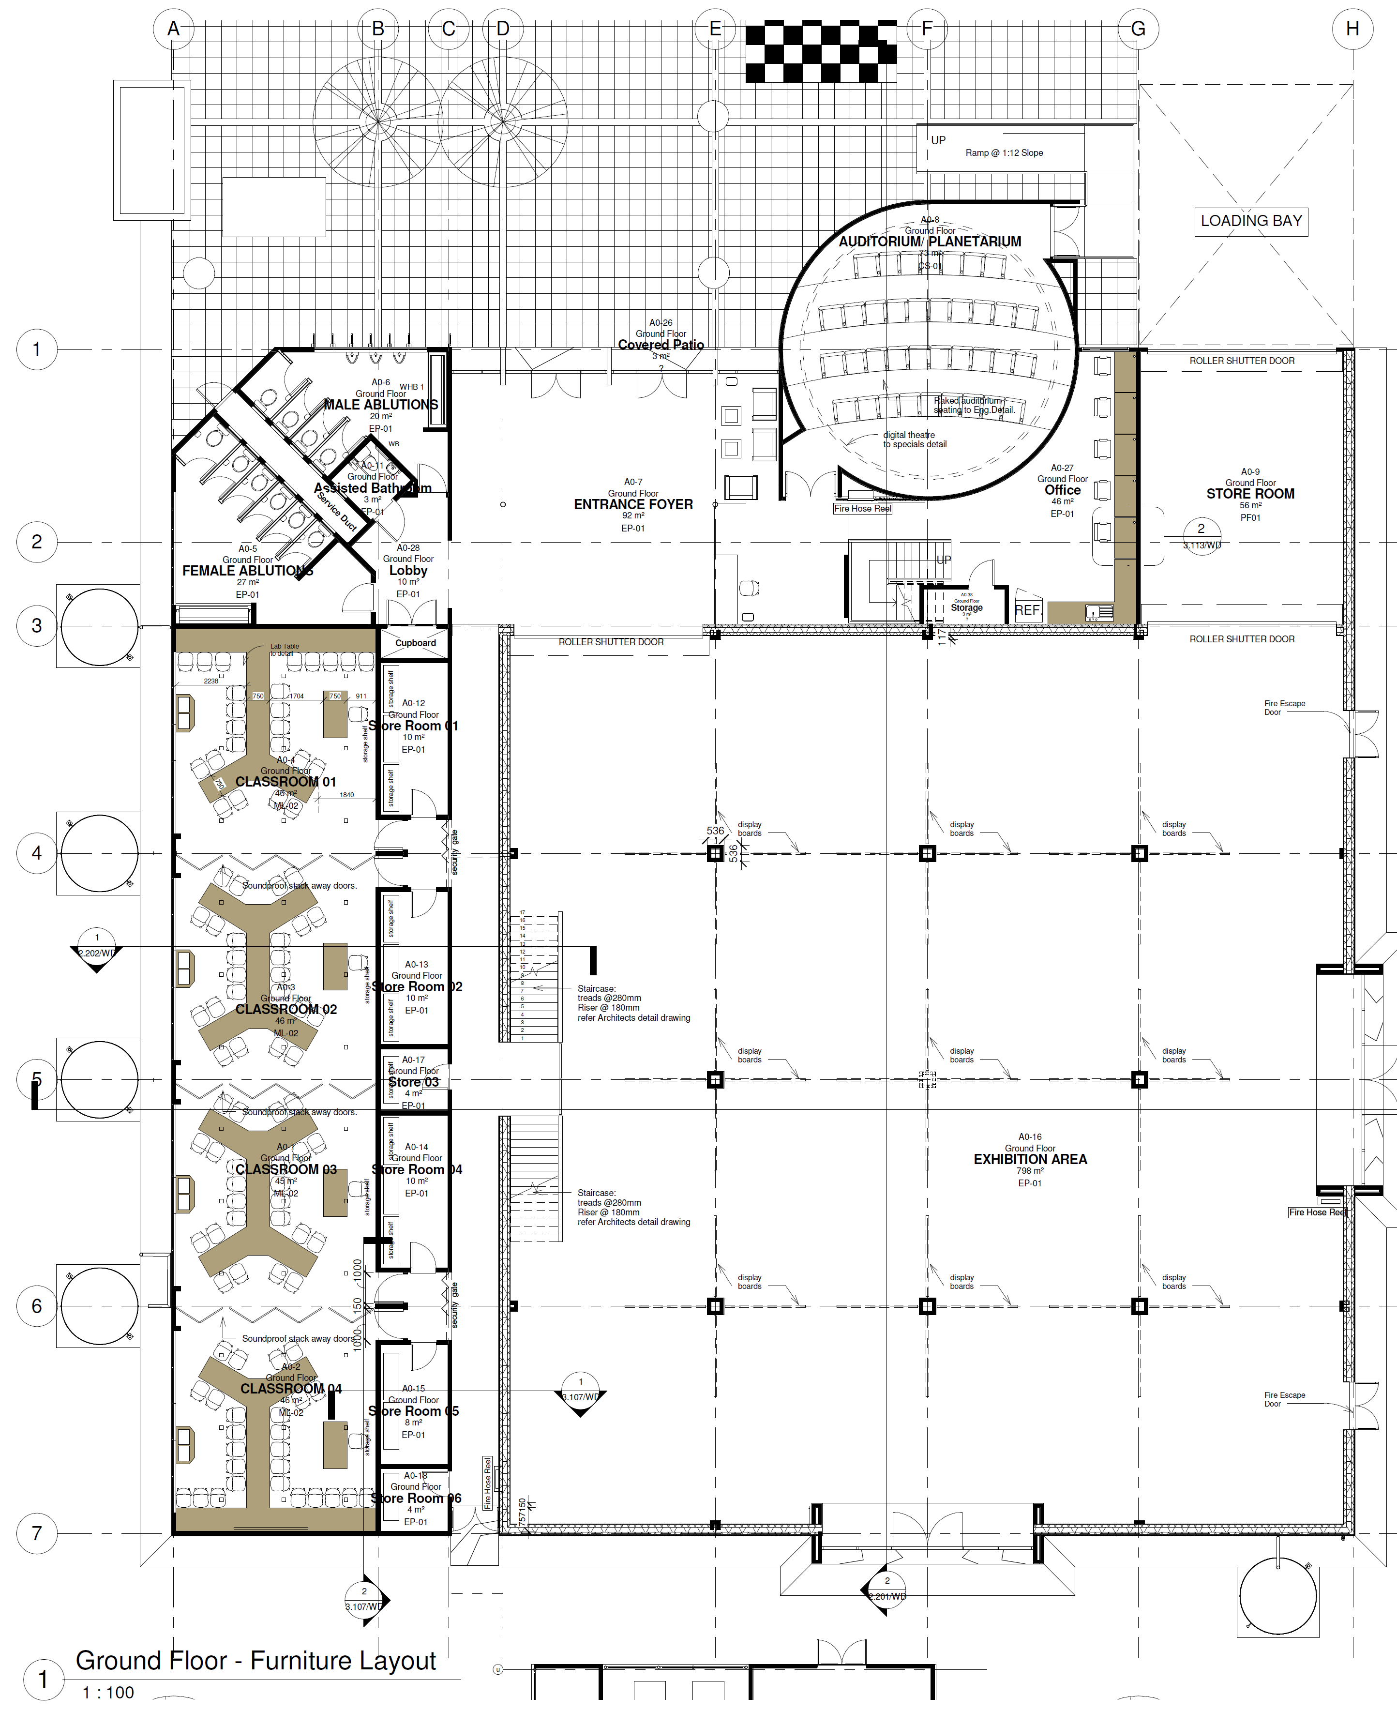

TARGET PUBLICS

The sections of society being targeted for participation are:
- Learners
- Educators
- Science interpreters
- Journalists
- General public
- Decision-makers
- Students
- Industry
- Tourists
- Indigenous knowledge holders
- Researchers and scientists

STRATEGIC PROGRAMME GOALS

The Cofimvaba Science Centre will form part of the network of science centres and play a significant part of the science engagement landscape, by having interactive and hands-on exhibits and related programmes, the centre will provide a platform for society to engage with Science Engineering and Technology (SET) and thus address the four strategic goals of science centres that are aligned to and supported by the Department of Science and Innovation (DSI). These strategic goals include:
- Promoting science awareness among the youth and general public;
- Identifying and nurturing talent and potential;
- Providing mathematics, science and technology support;
- Providing SET career education.

CANCELLATION OF THIS CALL PRIOR TO AWARD

NRF reserves the right to cancel the award prior to issuing the funding letter and signing the contract form.

CONTRACT PERIOD

The period commences from the date that both parties sign the contract and the contract period will end based on the time lines agreed with the grant holder.

LIST OF EXHIBITS AND GRANT HOLDER DETAILS

Please refer to ANNEXURE A and ANNEXURE B for the details of the exhibits that must be supplied and the form for the details of the grant holder.

DETAILED REQUIREMENTS FOR SCIENCE EXHIBIT DEVELOPMENT

The interactive science exhibits are required to use various communication approaches to communicate science, technology and innovation to visitors of the Cofimvaba Science Centre. Grant holders will be required to deliver and install these at the Cofimvaba Science Centre and verify that the delivered exhibits meet the objectives set out in this document. Each exhibit must be inclusive of their exhibition user manuals, graphic designs, furnishings, signage, user instructions, and labels. SAASTA will approve the final exhibition branding and signage.

- Delivery timelines
  - The grant holder must provide an indication of the timeline required for development of each exhibit.
  - The grant holder must provide an indication of the delivery requirements for each exhibit to be transported to the Cofimvaba Science Centre and for the installation of the exhibit.
  - The grant holder must provide a project plan for grant evaluation purposes demonstrating how they will deliver and install the exhibits within 90 days.
  - The grant holder has to include in its project plans the minimum of project resourcing, timeframes for manufacturing, installation and delivery.
  - SAASTA will agree on the final project delivery plan with the grant holder after the signing of the contract form.
- Supply, delivery, training and installation of exhibits
  - The grant holders must ensure the supply, deliver and installation of the proposed science exhibits.
  - Each exhibit should include an exhibition maintenance and user manual, graphic design, furnishing, signage, user instructions and labels of an interactive exhibition.
  - The grant holder will be expected to provide training on the installation and use of the exhibits.
  - Grant holders can supply one or more of the exhibits outlined in this document.
- Branding
  - The science exhibits will be co-branded between SAASTA, DSI and grant holder branding. Branding guidelines will be provided to all grant holders and final approval of branding must be obtained from SAASTA prior to manufacture.
- General requirements of proposed exhibits
  - Proposals must provide details of the interactive nature and educational messages of each exhibit.
  - Proposals must include a minimum of the following sections:

GRANT PROPOSAL FOR DEVELOPMENT OF SCIENCE EXHIBITS FOR COFIMVABA SCIENCE CENTRE
1 | PURPOSE/AIM OF EXHIBIT/S
2 | DESCRIPTION OF THE EXHIBIT/S
3 | DIMENSIONS OF THE EXHIBIT
4 | TYPES OF MATERIAL
5 | WORK SCHEDULE AND PROJECT PLAN (including delivery and installation)
6 | MAINTENANCE PLAN (including list of spare parts to be supplied)
7 | STAFF TRAINING
8 | FUTURE UPGRADES
9 | BUDGET (including an itemised cost breakdown and VAT and in rands )
10 | EXHIBITION USAGE INFORMATION

- Budget
  - Funding Allocation Ceiling/Award Cap: For determining allocation of funding support, NRF-SAASTA reserves the right to determine the funding ceiling for each grant holder, utilising the proposal and funding application request.
  - Only one proposal per organization will be considered, unless submitted by separate sections of the organisation with distinctly different mandates or research foci.

- Maintenance of exhibits
  - The Cofimvaba Science Centre manages the exhibits and will repair minor exhibit malfunctions however the grant holder takes responsibility for major maintenance and general oversight of the science exhibits.
  - Cost for ongoing maintenance must not be included in the budget of this grant call and such funds will be made available by SAASTA when necessary and following approval of such costs at the discretion of SAASTA.
  - The supply of an initial set of spare parts should be included in the budget of this call.

- Verification of the installed exhibits
  - The appointed grant holder must notify SAASTA after completion of the exhibit before installation at the Cofimvaba Science Centre.
  - SAASTA contract manager will arrange the verification session with the grant holder.
  - The grant holder will demonstrate each installed exhibit to the SAASTA verification team and demonstrate each exhibit is in line with what the grant holder agreed to in their grant proposal.
  - The grant holder must correct any defect agreed upon by both parties from the verification session.
  - The grant holder will notify SAASTA when the corrected exhibit is available for verification.
  - SAASTA will only pay for those exhibits where SAASTA and the grant holder have agreed that the exhibit meets the requirements of this call.

- Packaging and transport
  - The grant holder will pack the exhibits, protecting against any risks to the exhibits
  - Grant holder will collaborate with SAASTA on the transport of the exhibits to Cofimvaba Science Centre for installation after confirming the requirements and details for such transport with the grant holder.

- Transfer/hand over from SAASTA to the Cofimvaba Science Centre
  - The grant holder, a representative of the Eastern Cape Department of Education, DSI and SAASTA will conduct the handover of the installed exhibits to the management of the Cofimvaba Science Centre.
  - The Cofimvaba Science Centre’s management will record the handed over exhibits into their asset register and will provide SAASTA with a signed copy of such as evidence of SAASTA and the grant holder having performed their obligations to the Cofimvaba Science Centre.

BRANDING

All branding must ensure the following:
- All documents/items to be developed for the project, e.g. notes, forms, programmes, etc., must comply with the branding rules as set out in the contract.
- The successful applicant agrees, for publicity purposes, to use the DSI and NRF-SAASTA on all materials (this includes educational material) produced for this project. Logos are available for download from: http://www.saasta.ac.za/resource-centre/logo-library/. The DSI logo must be in the most prominent position, with the NRF-SAASTA logo and the grant holder logo respectively, to follow. The grant holder logo and the NRF-SAASTA logo must be smaller than the DSI logo. This information can be found in more detail in the branding guideline document. All documents must be submitted to NRF|SAASTA for approval prior to printing in order to ensure correct branding. Submit to Mr. Happy Vilakazi, happy@saasta.ac.za, 012 392 9317/00 and Njabulo Duma, njabulo@saasta.ac.za, 012 392 9300.

PROJECT REPORTING REQUIREMENTS

- Submit a narrative report within six weeks after the project completion and final installation of exhibits.
- Narrative report must specifically include the following sections:
  - Project performance against project proposal
  - Achievements against desired training and capacity building objectives
  - Project challenges and mitigation
- Financial report:
- Financial reports must include a financial statement, visibly approved, by a qualified Accountant who is registered with an accounting body in South Africa e.g.: Chattered Accountant, Accounting Technician, Professional Accountant (SAIPA, SAICA, etc). It is assumed that this individual is already part of the Finance Department for the organization and if that is not the case then the grant holder who decides to use this method of reporting should ensure that costs of the services in the form of quotations, will be submitted to NRF-SAASTA for assessment and a decision, prior to utilising the services of the accountants. If found to be both necessary and reasonable, pre-approval by the Finance Manager and Managing Director at NRF-SAASTA will be communicated to the grant holder. If no prior approval was obtained to use this method of reporting, then the grant holder will be subject to auditing by NRF-SAASTA or expected to automatically revert back onto the previous method of reporting by providing actual supplier slips, invoices and corresponding bank proofs of payment together with a financial report.

mandatory DOCUMENTS CHECKLIST

Bidder Eligibility Administration (M=Mandatory)
Proposal submission form (ANNEXURE A) | M | ❑Yes ❑No
Proposed budget form (ANNEXURE B) | M | ❑Yes ❑No

grant holder SELECTION PROCESS

Stage 1 – Compliance to submission requirements (MANDATORY)

DESCRIPTION | YES/NO
- The organisation has submitted all documents as set out in the Mandatory Documents List
- The organisation belongs to the approved category as stipulated in the eligibility to apply

NB: If all the responses above is yes, the organisation will go through to Stage 2 of evaluation

Stage 2 – Evaluation of Proposals against Technical Specifications

- Stage 2A – Evaluation of Proposals against the requirements of the Call
Only potential grant holders meeting or exceeding the minimum threshold of 60% in the evaluation criteria set out in this document, are selected for financial support without any revision, where revision is applicable.

- Stage 2B – Revision of their Proposals
NRF-SAASTA reserves the right to communicate recommendations/queries and the right to request the qualifying (in terms of threshold and stages 1 and 2A of the selection process) potential grant holder to provide a revision of certain aspects of their original proposal in terms of such recommendations/queries and for this revision to be returned to NRF-SAASTA as per the instructed deadline provided in the feedback.

Stage 3 – Funding Award and Contract Signing

NRF-SAASTA will enter into a grant funding contract with approved grant holders.

EVALUATION criteria
(THE FOLLOWING ELEMENTS WILL BE LOOKED AT DURING EVALUATION OF PROPOSALS)

ELEMENT | SCORE | WEIGHT | WEIGHTED SCORE
- PURPOSE/AIM OF EXHIBIT/S:  Description Rating  No information 0  Purpose of the exhibits does not align to the objectives of the science centre 1  Purpose of the exhibits aligns to 1 objective of the science centre 2  Purpose of the exhibits aligns to 2 of the objectives of the science centre 3  Purpose of the exhibits aligns to 3 of the objectives of the science centre 4  Purpose of exhibits contributes significantly to all the objectives of the science centre 5 |  | 20
- DESCRIPTION OF THE EXHIBIT/S TYPES OF MATERIAL  Description Rating  No information 0  The description of the exhibit/s shows no interactivity and limited durability 1  The description of shows some interactivity, limited durability and provides a limited educational learning output. 2  The description of shows interactivity, durability and provides an educational learning output. 3  The description of shows significant interactivity, high durability and educational learning output. 4  The description of shows significant interactivity, high durability and provides an information and highly educational learning output. 5 |  | 30
- WORK SCHEDULE AND PROJECT PLAN (including delivery and installation)  Description Rating  No information 0  Work schedule included with limited information. 1  A work schedule with timelines including delivery requirements. 2  A detailed work schedule with timelines including delivery and installation requirements and a limited project plan. 3  A detailed work schedule with precise timelines including delivery and installation requirements and a detailed project plan. 4  A detailed work schedule with precise timelines including delivery and installation requirements and a detailed project plan. 5 |  | 30
- MAINTENANCE PLAN (including list of spare parts to be supplied) and STAFF TRAINING  Description Rating  No information 0  A limited maintenance plan included 1  A maintenance plan and limited staff training plan included 2  A maintenance plan including proposal for the development of user manual and limited staff training 3  A detailed maintenance plan including proposal for the development of user manual and staff training 4  A detailed maintenance plan including proposal for the development of user manual and comprehensive staff training 5 |  | 20
TOTAL | /20 | 100 | / 100

ANNEXURE A: Proposal Application and Submission Form
Name of the institution | Exhibit number/name (listed in Annexure B)

Please complete all fields of this form, stating N/A (not applicable) where appropriate. Additional information may be provided at the end of the document.
Organisations’ Background Information
Name of Organisation / Institution
Type of Organisation / Institution | ☐ University  ☐ Museums, Botanical Gardens and Zoos  ☐ Science Councils
Organisations’ Physical Address
Organisations’ Contact Details
SECTION A: ORGANISATION PROFILE

General Project Administration Information
Authorised Signatory for Organisation / Institution | Name | Position
Name and designation of Project Financial Administrator | Name | Position

Organisation / Institution Banking Details – these details must be the same as the CSD report
CSD reference number (MAAA…)
Name of account holder
Type of account
Name of Bank
Branch
Bank Branch Code
Bank Account Number
Details of Project Leader
Title
Full Names Surname
Current Position in the Organisation / Institution
Similar Projects Undertaken Previously (if any)
Contact Number (Landline and Cellular Phone)
E-mail Address
Physical Address
Highest Academic Qualifications
Brief Career History
Number of team members assisting Project Leader
Alternative Contact Person if Project Leader is Unable to Complete Obligations:
Name and Surname |  |  |  | Designation
Email Address |  |  |  | Office / Mobile Number
Details of Project Team (add more rows if needed)
List the potential team members |  |  | Highest Qualification and Relevant Experience |  | Responsible for

SECTION B: GRANT PROPOSAL
GRANT PROPOSAL FOR DEVELOPMENT OF SCIENCE EXHIBITS FOR COFIMVABA SCIENCE CENTRE
1 | PURPOSE/AIM OF EXHIBIT/S
2 | DESCRIPTION OF THE EXHIBIT/S
3 | DIMENSIONS OF THE EXHIBIT
4 | TYPES OF MATERIAL
5 | WORK SCHEDULE AND PROJECT PLAN (including delivery and installation)
6 | MAINTENANCE PLAN (including list of spare parts to be supplied)
7 | STAFF TRAINING
8 | FUTURE UPGRADES
9 | BUDGET (including an itemised cost breakdown)
10 | EXHIBITION USAGE INFORMATION

ANNEXURE B
 | EXHIBIT NAME (CONCEPT) | DESCRIPTION (Brief) | DIMENSIONS
1 | Ecology  (Outdoor Exhibition)  Development of Wetland | Development of wetland on the boundary of the Science Centre, which could be used as a wet lab and for practical experience by the learners visiting the Science Centre. The wetland will furthermore educate learners, students and community on erosion, wetland, and related environmental factors. There is a need for storyboards and a practical learning experience for visitors to the Science Centre.  The proposal must satisfy the following core concepts:  NB: the following items must be budgeted for individually  - Development of education boards with walkways and landscaping on site. Planned and designed as an educational “tour” for learners with practical viewpoints on the existing site, with the corresponding teaching / information that will both advise the learner and teacher who will be conducting the “tour”.  - A practical on site illustration of erosion management accompanied with educational boards. This will form part of the ‘tour’. The intention is to take out a portion of the retaining embankment to visually demonstrate the soil, bedrock layering and planting etc. present and required, to prevent erosion and be beneficial to the natural landscape (water retention, plant types, indigenous planting and practical low cost approaches to prevent soil erosion and increase retention). Plant indigenous wetland plants that include the categories of emergents, floating, and submerged plants. Wetland plants such as such as cattails, water lilies, bull tongue, sedges, tamarisk, and many kinds of rush to be part of the package.  - Landscape large portions of the site with indigenous grasses, trees and other plants to serve as an outdoor ecological classroom. The plant species will include plants of medicinal value.  - A 1,2m x 1,2m infographic and stand/frame: The infographic must be a replica of this wetland showing its full layout and information to help the visitors understand the wetland’s details and key messages.  - Fencing: the wetland area should be demarcated.  The development must be accompanied by interactive digital educational material for further learning covering topics such as water quality, green economy and innovation, environmental management, etc. | 16 m²
2 | Nanotechnology Applications | Development of the exhibit(s) to demonstrate the application of nanotechnology through the use of basic and integrated physical chemistry and aims at exploiting the opportunities offered by electrochemical technologies such as sensing and energy storage devices. The purpose of this exhibit is to demonstrate how nanomaterials with excellent electrochemical properties provides sustainable solutions to challenges associated with water pollution and clean energy production. These applications of the nanomaterials include bio/sensors, capacitive deionization, photo electrochemical reactors, supercapacitors and batteries. The exhibit must link the basic science from CAPS Curriculum to its deliverables. | 9 m²
3 | Bio-innovation Exhibition:  Application in Agriculture | Development of Bio-innovation exhibit to demonstrate its application in Agricultural sector in three main areas which are, Energy efficiency, indoor and urban gardening and water purification. The exhibitions should be linked to CAPS Curriculum as part of basic science, but interactive. The Curriculum-based hands-on activities for different grades must be clearly articulated.  Major focus:  NB: the following items must be budgeted for individually  - Hydroponic System: (outside).  - Design and constructions of an outside hydroponic model (25 m²) of hands-on bio-innovation with live plants such as a variety of vegetables that can be grown using this system, including leafy greens (Swiss chard, kale and mustard spinach) and tubers (beetroot, onion and potato). For most vegetables (particularly leafy greens).  - Water purification model: Phytomediation (indoor)  - Phytoremediation is the use of green plants for removal of pollutants from water or soil to a safer level in the environment. All plants in general, and those with greater biomass and larger root surface areas in particular, are capable of effectively removing both organic and inorganic pollutants from water and soil.  - Renewable energy: Biogas (indoor)  - A 1000 L biogas digester to be positioned outside the building and connected into the building where the demonstration stand will be based. The stand should have a gas stove for demonstration. The biogas contains high content of methane gas, which is flammable and convertible into energy for cooking, heating and electricity. | 25 m² (hydroponic a)  9 m²  (indoor b, c)
4 | Bio-innovation Exhibition:  Application in Life Science and Microbiology | The exhibit to demonstrate the applications and processes that are followed in scientific research space. It should breakdown the basic biology of aspects such as human cells, microbes, DNA/RNA and proteins, Protein Synthesis Process – using microscopes and other apparatus used in the labs. This should provide the visitors with an opportunity to understand the behaviour of viruses in the cells with reference to COVID-19. The exhibit will further demonstrate how virus attack the cells, mutation and formation of new variants. This must also be aligned and link CAPS Curriculum topics.  Other considerations are:  - Life processes  - Life systems  The exhibition stand will have a background wall that explains how life forms, how life develops, and the characteristics of life as explained by the concepts, processes and systems.  The videos contents will showcase and teach about the following; atoms, molecules, genes, organelles, cells, tissues, organs, organ systems, organisms, populations of species, diversity of species.  The exhibition stand will have a background wall that explains how life forms, how life develops, and the characteristics of life as explained by the concepts, processes and systems. | 9 m²
5 | Paleoscience Exhibition | The development of an interactive exhibition covering various aspects of the palaeosiences for an audience who may not know what a fossil or even a dinosaur is. The exhibits should be a clear demonstration of South Africa’s contribution globally in the field of Paleoscience. The discoveries that made headlines in the whole world. The exhibit must display the South Africa’s hidden treasures is its incredible record of geology, fossils and artefacts extending over more than 3.5 billion years which tell how life evolved from its origins through four-legged fish, dinosaurs, mammal-ancestors to humans with modern thought processes.  NB: the following items must be budgeted for individually, meaning that each section must have its own budget estimate,  - A large ($±$3.5 m x 2 m) map of South Africa showing the key events in the history of life (from the school curriculum) using eye catching pictures and symbols.  - 10 x A0 posters explaining what a fossil is and the different types of fossils, how they are formed, and the special fossils found in the Karoo and the Cradle of Humankind. These posters will be designed from scratch.  - 10 x A0 posters describing what fossils can tell us. There will be poster on the Age of the Earth, Climate Change, Global Warming, Mass Extinctions, Evolution, Innovations that came out of Africa: fire, tools, the bow and arrow etc.  - All posters and the map will printed on vinyl and supported by an aluminium frame.  - A multimedia component (funded from other sources). Each poster will have a QR code which when scanned gives details of the content of the exhibit.  - Three tables with specimens that learners can touch and feel. Including:  - A table of real fossils  - A table of high-quality replica fossils from the Karoo  - A table of high-quality replica fossils from the Cradle of Humankind  - All specimens will be reinforced and the tables will be constructed in such a way that the learners will be able to handle the specimens without damaging them or themselves.  - 3D map showing key fossil localities in South Africa.  - 3D projection-mapped video projected on table or Magnetic Self Adhesive Poster  - Dimensions to be within the projection space  - Interactive multimedia desks with touch screen and audio outputs below each banner/wall poster to include:  - Additional information and pictures and videos for each topic  - Quiz feature  - 3D virtual tour of locality where applicable  - Screens to display the paleo science content  - Speakers to produce an automated activated sound at a pass of an object  - Sound giving segmented information in 5 minutes intervals  - Controller to change the segmented messages  - Dracovenator the dragon—hunter (length 9 m, hight 2 m) | 25 m²
6 | Robosanitizer: | Supply of Sanitisers Stands:  NB: the following items must be budgeted for individually A robot to be placed at the reception which has capability to detect people and remind them to sanitize by sensing them when passing a certain point. The Robots will detect fever, dispense hand sanitizer. The robot should be 1 meter tall/height. It must have wheels and be able to move, and sensors to detect any obstacle to stop and/or change the direction.  - This exhibit should also be accompanied by the Spray Fogger is a super effective sanitising solution that saves you time and money.  - The Sanitising Fogger is light and portable (10kg with full 4,5litre sanitiser tank).  - The Sanitising Fogger is extremely cost effective – ULV (ultra low volume) technology ensures the least usage of chemicals with a 5-50microns size droplet.  - The Sanitising Fogger can access high and difficult to reach areas – 8m spray range.  The Sanitising Fogger is fast and efficient with spray rate of approximately 90 seconds per 100sqm.  - The Sanitising Fogger is reliable. Quality materials includes brass nozzles and industry leading Samsung 1330W engine. We also offer a 48 hour swap out service to ensure limited down time.  The Sanitising Foggers are extremely cost effective. 1 litre of Eco-Lyte Sanitiser costs R40 and can cover an area of approximately 1000sqm in about 12 minutes.  - 10 x automatic / step-on sanitisers
7 | Solar System | NB: the following items must be budgeted for individually  - Interior  The solar system exhibit will comprise of a 6m x 6m diameters (scaled down) solar system. The solar system will be floating on the roof. The exhibit will follow a circular layout with sun in the centre. The planet are to be distributed in a manner that allows for adequate space for many audiences to utilise the space without crowding. All the components of the exhibit must be durable and must be able to withstand harsh weather conditions.  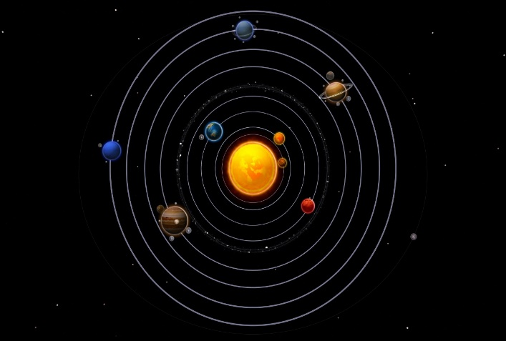  Images 1. Circular layout of Solar system exhibit.  - Exterior  Walking the solar system exhibit with all planets of the solar system. The placement of the planets will be calculated into the solar system scaled distances. The walk will be equated to moving from one planet to another taking the scale of time and distance (especially distance) into account. The following items should form the supply and delivery of the solar system:  - Paved walking area from one planet to another  - Planets placed on a weather resistant metal model  - The sun placed at the centre of the planets with a radius scale used to determine the sizes of the other planets. The dimension of the Sun should be 3 m in diameter and every planet be scaled down from the real system. However, the minimum planet size should not be less than 30 cm (diameter). Anything less than 30 cm (diameter) should be discussed with DSI/SAASTA exhibition team).  - A weather resistant Metal plaque in front of the stand with information about the planet  Planet  Plaque  Base (heavy slab)  Support Stand  Height of planet  Height of plaque  Image 2. Weather resistant Metal model of sun in the centre of the solar system  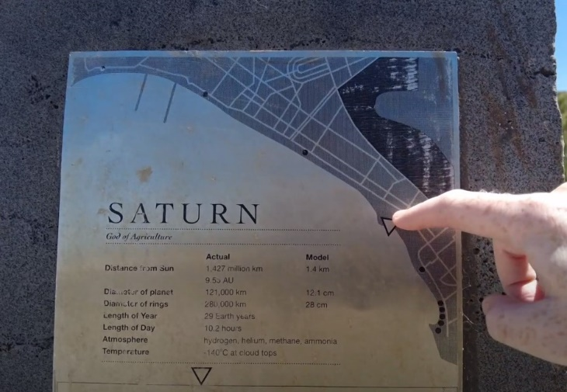  Image 5. Weather resistant Metal plaque on the front of the stand with information about the planet. | 6x6 m²
8 | Plasma Ball | - Your plasma ball is filled with mini lightning bolts that arc toward your fingers when you touch the surface  - A fabulously entertaining way to light up a room  - Available in plug-in Large 15 cm Globe  - The adopter change AC 220V to DC 12V  - Total Power:8W | 15cm Globe
9 | Lawn mower - cub cadet robot | The Cub Cadet XR3 Robotic Mower feature an extremely durable and rapid mowing system that meets optimal demands. This top-of-the-range model also include the unique edge mode whereby blades extend beyond the wheel base, ensuring that absolutely every edge is mown: no more having to manually tidy up afterwards with a lawn trimmer. The high-performance brushless motor operates at 2 x 200 watts and is extremely durable.
10 | Drone | Quadcopter Drone With 720P HD Camera Foldable Drone RTF - 3D Flip  Drone with Camera | 1 unit
11 | The Millex Intelivac | 3-in-1 Robot Vacuum, Sweep & Mop with Wifi for the centre. The Intellivac must do all the three - sweep, vacuum and mop.  Operations:  The device must vacuum, sweep and mop.  When the battery starts running low, the Intellivac must make its way back to its docking station to recharge itself.  It must come with five cleaning modes for us to choose from:  Auto clean  Z-clean.  Spot clean.  Edge clean.  Enhanced clean.  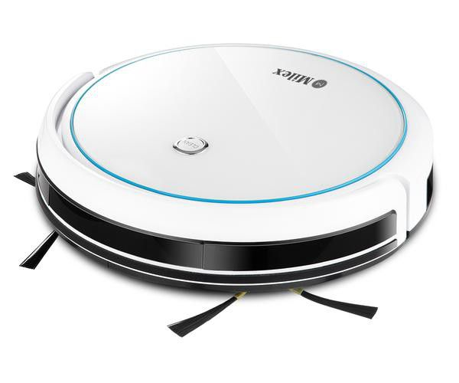 | 4 units

ANNEXURE C

# | EXHIBIT NAME (CONCEPT) | Quantity | Amount (including VAT)
1 | Ecology (Outdoor Exhibition)  Development of Wetland | 1
2 | Nanotechnology Applications | 1
3 | Bio-innovation Exhibition (Application in Agriculture) | 1
4 | Bio-innovation Exhibition (Application in Life Science and Microbiology) | 1
5 | Paleoscience Exhibition  - A large ($±$3.5 m x 2 m) map of South Africa showing the key events in the history of life (from the school curriculum) using eye catching pictures and symbols. | 1
 | - 10 x A0 posters explaining what a fossil is and the different types of fossils, how they are formed, and the special fossils found in the Karoo and the Cradle of Humankind. These posters will be designed from scratch. | 1
 | - 10 x A0 posters describing what fossils can tell us. There will be poster on the Age of the Earth, Climate Change, Global Warming, Mass Extinctions, Evolution, Innovations that came out of Africa: fire, tools, the bow and arrow etc. | 1
 | - All posters and the map will printed on vinyl and supported by an aluminium frame. | 1
 | - A multimedia component (funded from other sources). Each poster will have a QR code which when scanned gives details of the content of the exhibit. | 1
 | - Three tables with specimens that learners can touch and feel. Including:  - A table of real fossils  - A table of high-quality replica fossils from the Karoo  - A table of high-quality replica fossils from the Cradle of Humankind | 1
 | - All specimens will be reinforced and the tables will be constructed in such a way that the learners will be able to handle the specimens without damaging them or themselves. | 1
 | - 3D map showing key fossil localities in South Africa.  - 3D projection-mapped video projected on table or Magnetic Self Adhesive Poster  - Dimensions to be within the projection space | 1
 | - Interactive multimedia desks with touch screen and audio outputs below each banner/wall poster to include:  - Additional information and pictures and videos for each topic  - Quiz feature  - 3D virtual tour of locality where applicable  - Screens to display the paleo science content  - Speakers to produce an automated activated sound at a pass of an object  - Sound giving segmented information in 5 minutes intervals  - Controller to change the segmented messages | 1
 | - Dracovenator the dragon—hunter (length 9 m, hight 2 m) | 1
6 | Robosanitizer | 1
7 | Solar System
 | - Interior  The solar system exhibit will comprise of a 6m x 6m diameters (scaled down) solar system. The solar system will be floating on the roof. The exhibit will follow a circular layout with sun in the centre. The planet are to be distributed in a manner that allows for adequate space for many audiences to utilise the space without crowding. All the components of the exhibit must be durable and must be able to withstand harsh weather conditions.  Images 1. Circular layout of Solar system exhibit. | 1
 | - Exterior  Walking the solar system exhibit with all planets of the solar system. The placement of the planets will be calculated into the solar system scaled distances. The walk will be equated to moving from one planet to another taking the scale of time and distance (especially distance) into account. The following items should form the supply and delivery of the solar system:  - Paved walking area from one planet to another  - Planets placed on a weather resistant metal model  - The sun placed at the centre of the planets with a radius scale used to determine the sizes of the other planets. The dimension of the Sun should be 3 m in diameter and every planet be scaled down from the real system. However, the minimum planet size should not be less than 30 cm (diameter). Anything less than 30 cm (diameter) should be discussed with DSI/SAASTA exhibition team).  - A weather resistant Metal plaque in front of the stand with information about the planet  Planet  Plaque  Base (heavy slab)  Support Stand  Height of planet  Height of plaque  Image 2. Weather resistant Metal model of sun in the centre of the solar system  - Image 5. Weather resistant Metal plaque on the front of the stand with information about the planet | 1
8 | Plasma Ball | 1
9 | Lawn mower - cub cadet robot | 1
10 | Drone | 1
11 | The Millex Intelivac – can present as a 4IR exhibit – it can sweep, vacuum and mop. Serving both functions of cleaning in the centre as well as present as an exhibit. It is relevant to the exhibits needed at the centre. Due to the size and cost of the exhibit, it is possible to buy more than one exhibit – about 3 or 4 units | 4

