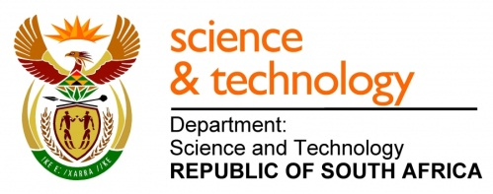
National Youth Service Programme
The Government of the Republic of South Africa adopted a National Youth Service implementation framework in March 2007. One of the objectives of the initiative is to give young people opportunities to develop skills through volunteering. Since the launch, there has been an increase in various government departments’ involvement. The Department of Science & Technology (DST) being one of the participants.
The National Youth Service Programme gives unemployed graduates (ages 18 to 35) an opportunity to strengthen, prepare and expose them to the working environment within the science, engineering and technology youth development programmes.
The usefulness of this programme has been confirmed repeatedly in practice. The benefits have become apparent by means of:
- Assisting unemployed graduates with employment so they can make a living
- Graduates are better equipped for their future careers, and become more employable through practical work experience, needless to mention more confident
- Specific talents can be identified and matched up with suitable opportunities
- Indecisive graduates get the opportunity to explore the various options open to them, while working productively
- Serves as a “stepping” stone for SET graduates to proceed in various careers.
The benefits are endless!
This programme has been successfully implemented for more than three years now with overwhelmingly positive feedback.
The DST has given SAASTA a mandate to implement the second phase of the National Youth Service Programme (YSP2).
On behalf of DST, SAASTA is inviting unemployed Science, Engineering and Technology graduates to apply to volunteer their services at different host institutions that are currently participating in the YSP2 nationally. This will grant our youth an opportunity to strengthen and develop their skills, thus preparing and exposing them to the working environment.
Graduates!
INTERESTED GRADUATES:
Interest youth who meet the qualifications should forward their CV with covering letter, certified copies of ID and qualifications and province of the choice. Candidates must ensure all contact details are included:
Human Resources Volunteer Department
South African Agency for Science and Technology Advancement (SAASTA)
1st Floor Didacta Builiding
Volunteers will receive a stipend per month based on qualifications:
- National Diploma R4000
- Bachelors Degree / B Tech R4500
- Honours R5000
- Masters R6000
- PhD R7200

211 Nana Sita Street (AKA Skinner Street)
PRETORIA
0001
Fax: 086 238 8924
Email: Irene@saasta.ac.za

TO VIEW CURRENT PARTICIPATING HOST INSTITUIONS CLICK ON THIS ICON:

